Voxone user guide

- Login to your Voxone app, You will be presented with the screen below. Type in your username & password.
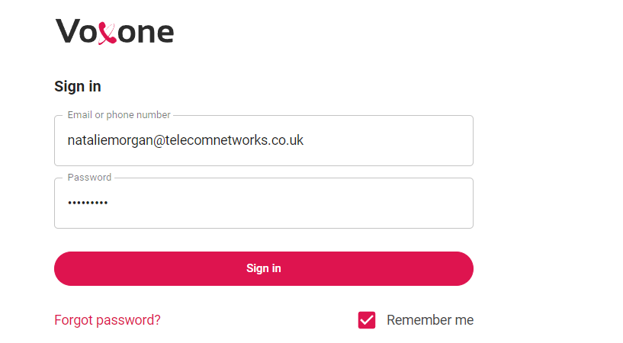

- Once you have signed in you will see the dashboard below, as you can see all contacts are listed here if you are calling someone from the directory you can type their name into the search box – if you are calling an external number not saved in the directory you can either type the number into the search box or use the keypad button I’ve circled below it will come up a green box with a logo of a phone, you can then press this to start your call.
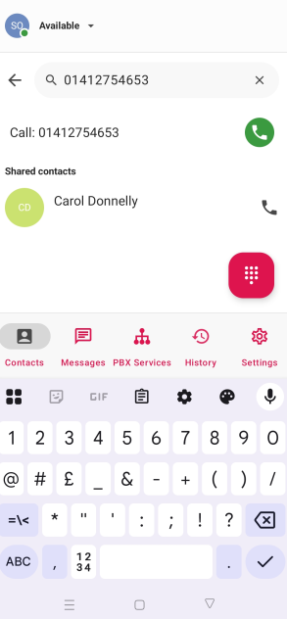
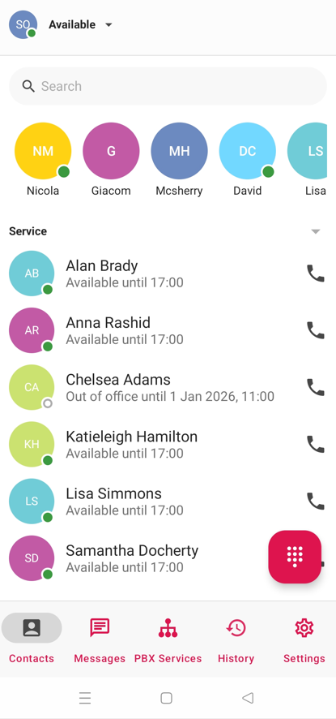

- Once your on a call it will look like the below screen. Here you can see the hold, transfer & mute options (See below)
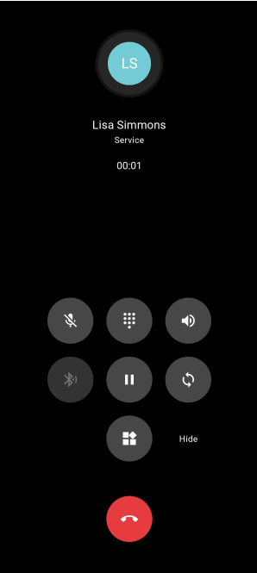

To place a call on hold, press the below key
To resume the call press the key again. 

To transfer a call, first put the call on hold then press hide, you will then see the screen below
with this screen you can either transfer to an internal colleague or you can type an external number in the search box.

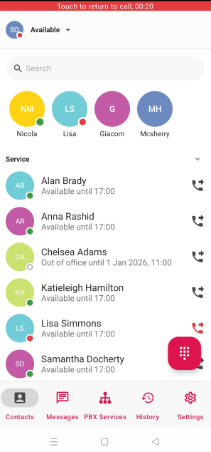

For this e.g. I would like to transfer my call to Alan Brady – so I click on the phone icon with the arrow, and you will see the below screen

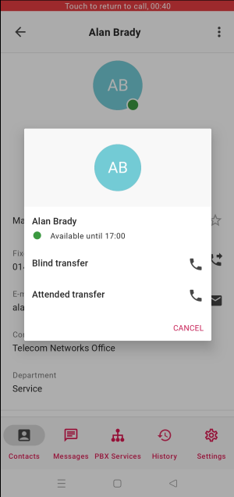
Blind transfer will just transfer the call without speaking to the person first.
Attended means you can speak to the person and say who you have on the phone and allow them to say yes or no to the call. If they say no, then just hit cancel and you have the original call back.

